Study Design
Design Type | Randomized, double-blind, placebo-controlled, parallel-group study.
# Treatment Arms | 2, active & placebo
Randomization Ratio | 1:1 (Active:Placebo)
Stratification & distribution assumptions | Body Weight (BW) Strata Study Distribution Regional Distribution  <90kg 76%, n=190 EU: 70 China: 120  >=90kg 24%, n=60 EU: 30 China: 30
Blinding | Double-blind (patients, investigators, and sponsor blinded)
Population
# Patients | Total: 250
# Countries | 14
# Sites | 100
# Depots | 2 regional/local depots: EU and China
#Patients/Regional Depot | EU n=100, China n=150
Treatment Duration
Patient Duration | 52 weeks
Study Duration  (1st Subject 1st dose to Last Subject last dose) | need to know to determine if one manufacturing run will support the full study timeline
Recruitment Assumptions
Recruitment duration | 2 years
Screening period | 10 days or less
%Screen Failures | 35%
%Sites who will not actively screen | 15%
Dosing & Dispensing Schedule
Dispensing | BW<90kg | BW>90kg
Baseline + Weeks 1-12  (dispense weekly)  13 dispensing events | ACT: 3 kit 3ml  PBO: 3 kit 3ml | ACT: 5 kit 5ml  PBO: 5 kit 5ml
Weeks 13-52  (dispense every 2 weeks starting at Week 14)  10 dispensing events | ACT: 1 kit 4.5ml  PBO: 1 kit 4.5ml | ACT: 1 kit 7.5 ml  PBO: 1 kit 7.5ml

At weeks 12 & 24 | Non-responders on ACT arm, continue weekly dosing according to BW for 3 additional weeks before moving to visits every other week.  Non-responders on PBO arm, switch to ACT treatment arm according to BW with weekly dosing for 3 weeks then switch to every other week dosing.  At week 12 weekly dosing would be Weeks 12, 13, 14.  At week 24 weekly dosing would be Weeks 24, 25, 26.
Supply Chain Considerations
Depot Structure
EU Depot | Supplies 13 countries in Europe and acts as the primary hub
China Depot | Supplies China only, but all IP must first ship to EU depot before being forwarded to China depot
Shelf Life for Investigational Product (IP)
From manufacture | 24 months
Minimum remaining shelf life for receipt by | EU depot: 6.5 months  China: 12 months  Sites: 6 months
Manufacturing & Release Timelines
Signal to manufacture | 6 months
Time from manufacturing to “ready-to-ship” status (including packaging, labeling, and QA release) | 4 months
Lead time (LT) from manufacturing to EU depot | 1 week
Lead time (LT) from EU depot to China depot | 2 months
Depot-to-site LT | <10 days for all countries
Labeling | Same label group for China and EU countries (single multilingual label set)
Supply/Re-supply
Start Up Supply | EU Depot: X months of supply  China Depot:  Sites:
Re-Supply Strategy | Strategy Logic Characteristics  UORO Use 1 → Replace 1 Simple, stable inventory, minimal complexity  Min/Max Refill when inventory < threshold Common for medium/large trials  Predictive Use enrollment forecast to decide resupply Efficient but algorithmically complex, predictive use over next x time period  Just-in-Time
Stock Out Tolerance % | 5%
Manufacturing
Raw Drug made per manufacturing run | X ml, or kg or tablets etc.
Formulation | 1st generation, 2nd generation
Dose(s) | 0.375mg / ml
Volume | 3ml, 4.5ml, 5ml, 7.5 ml
Route of Administration | IV, subcutaneous, intramuscular, intrathecal, inhaled, oral, topical, buccal, etc.
Kit types & number needed per type | Table represents maximum expected assuming full enrollment and all patients complete all dispensing visits.  Body Weight (BW) Strata Study Distribution Depot Distribution  <90kg (n=190) 3ml: 3 kits x 13 dispensing x 190 patients = 7,410 kits EU: 70pts, 2730 kits China: 120 pts, 4,680 kits  4.5ml: 1 kit x 10 dispensing x 190 patients = 1900 kits EU: 70pts, 700 kits China: 120 pts, 12,000 kits  >=90kg (n=60) 5ml: 5 kits x 13 dispensing x 60 patients = 3900 kits EU: 30 patients, 1950 kits China: 30 patients, 1950 kits  7.5ml: 1 kit X 10 dispensing X 60 patients = 600 kits EU: 30 patients, 300 kits China: 30 patients, 300 kits
Costs ($)
Manufacturing (raw drug supply) costs | Costs for one manufacturing run  how many kits can be made from a “standard” raw drug manufacturing run
Kit Pack & Label costs | Will all raw drug be packaged and labeled when manufacturing is completed.
Cost per shipment (Manufacturing to depot) | #kits/shipment (may vary based on initial supply and resupply strategy)  What is the kit storage capacity at the depots?

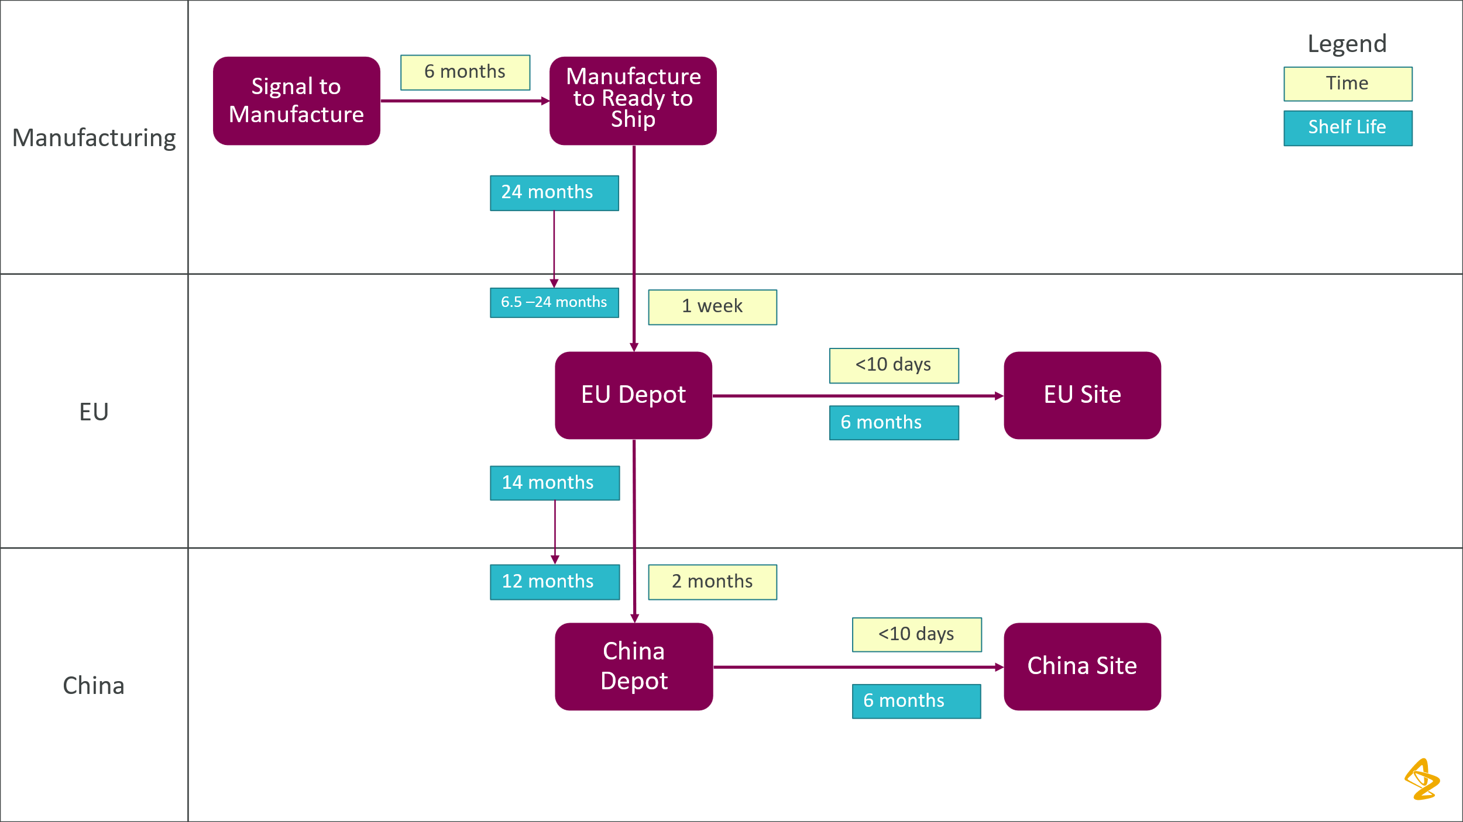

Main Components and Weighting
Drug minimization(w₁) + Costs(w₂) + Stock Out Tolerance(w₃)

